Priming the Fuel Pump.

From the main screen press the “OK Button” and the “Down Arrow Button” at the same time. It will bring up a screen that says “H oF”
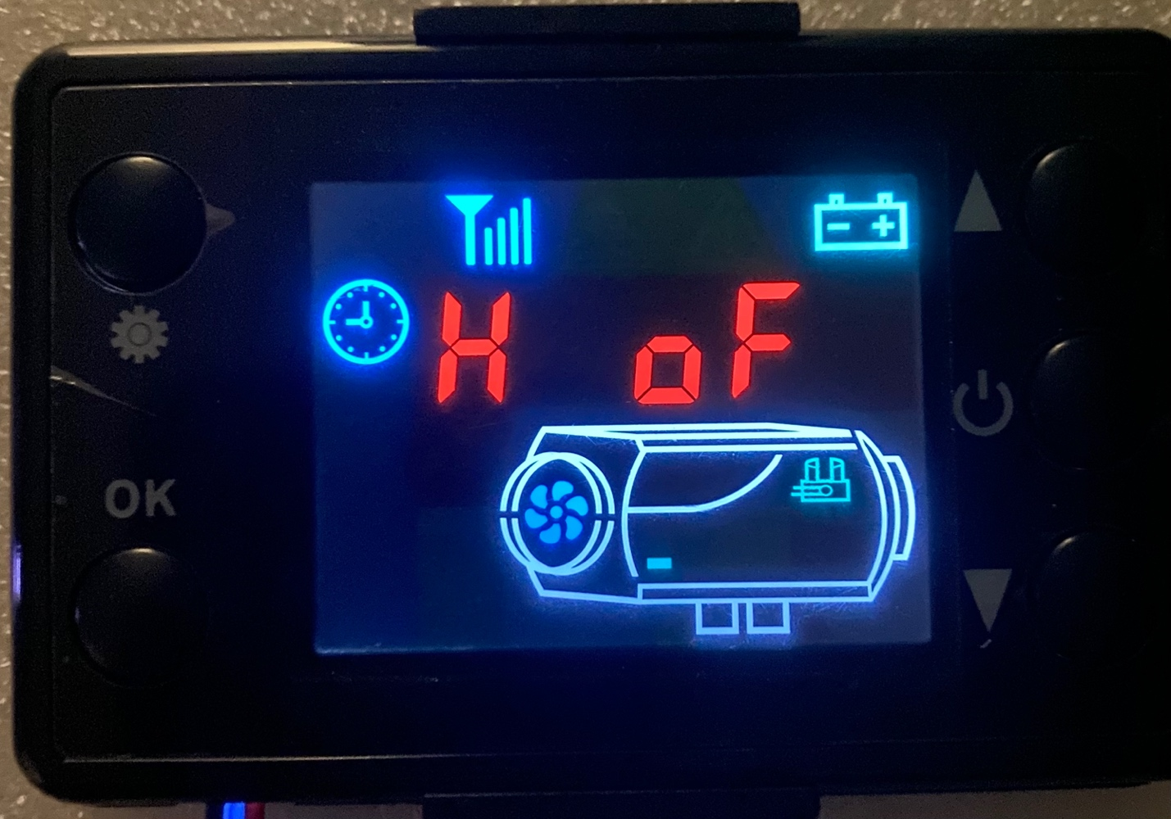

Press the “Up Arrow Button” and the value will change to “H on” at this point the fuel pump will start to make a clicking noise and you will see fuel moving through the lines.
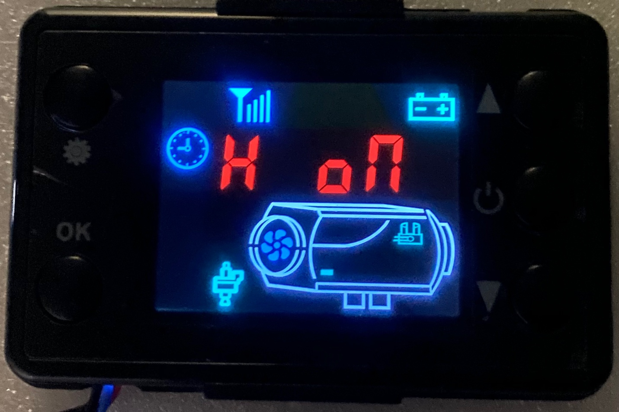

Once the fuel has filled the lines press the “Down Arrow Button” the screen will read “H oF” and the fuel pump will stop clicking.

Press the OK button to get back to the home screen.
